1. Create Table on the basis of table and data given above. Data types and size have to be decided by you and may vary.

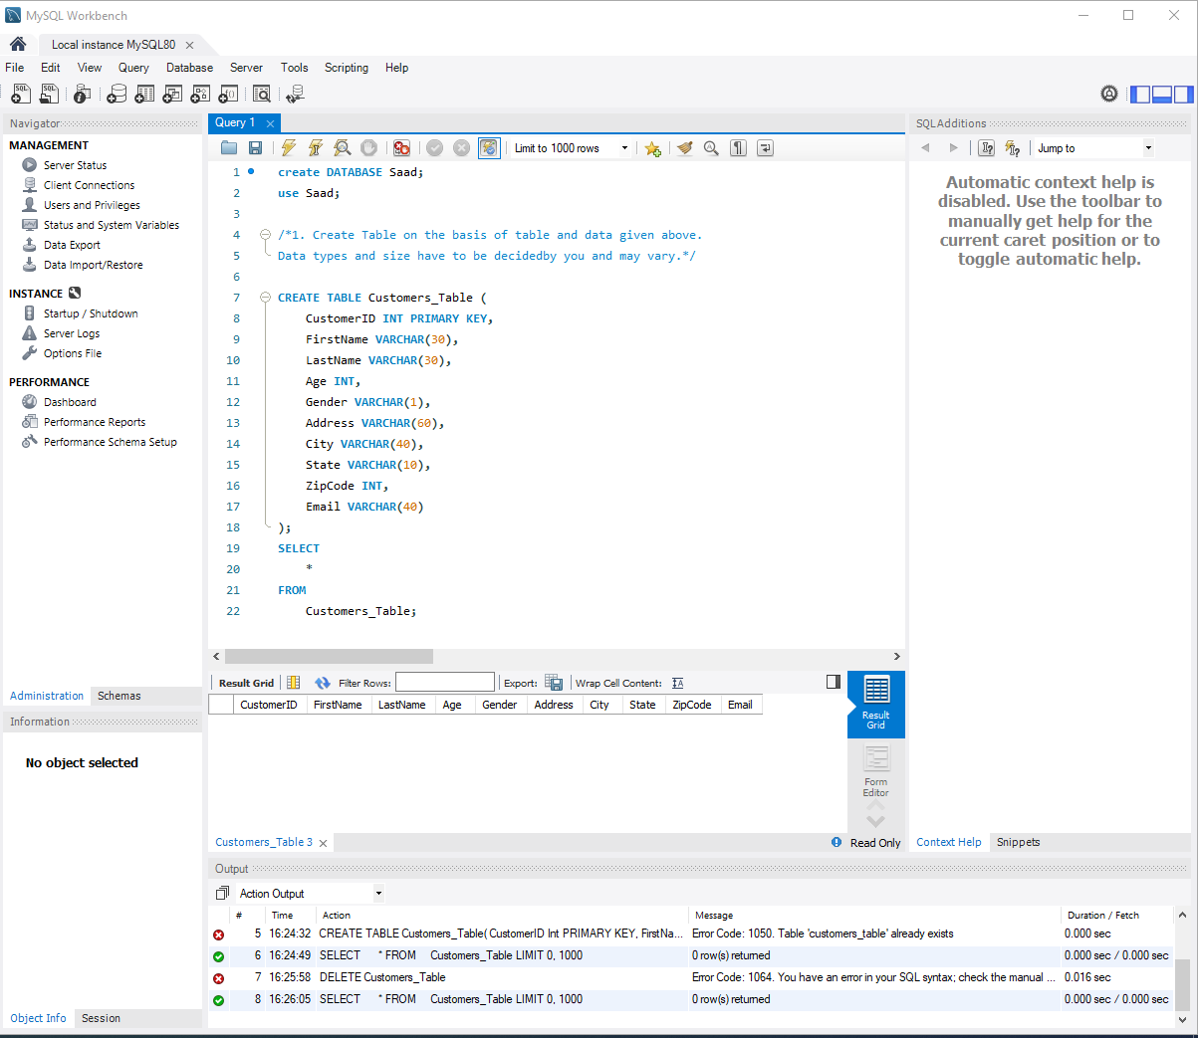

2. Also Insert data into table as described above.

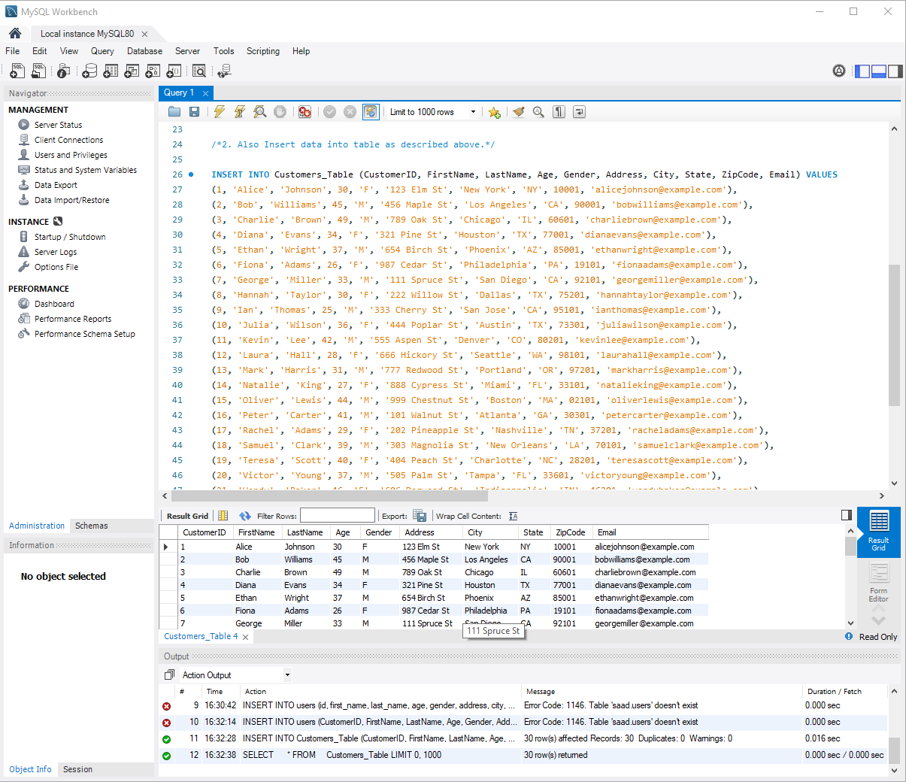

3. Write an SQL query to remove all data from the Customers table but keep the structure intact.

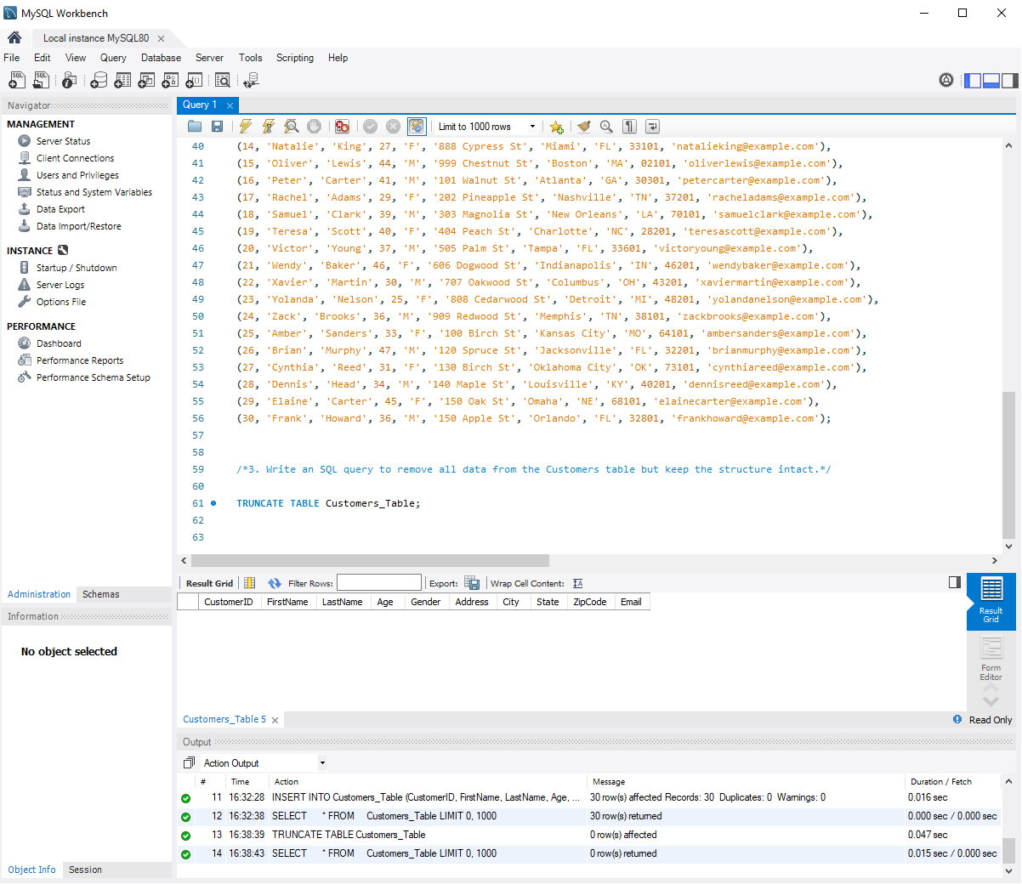

4. What is the key difference between TRUNCATE and DELETE?

Ans. The DROP TABLE command deletes a table in the database. The TRUNCATE TABLE command deletes the data inside a table, but not the table itself.

5. Write an SQL query to find customers aged between 25 and 45.

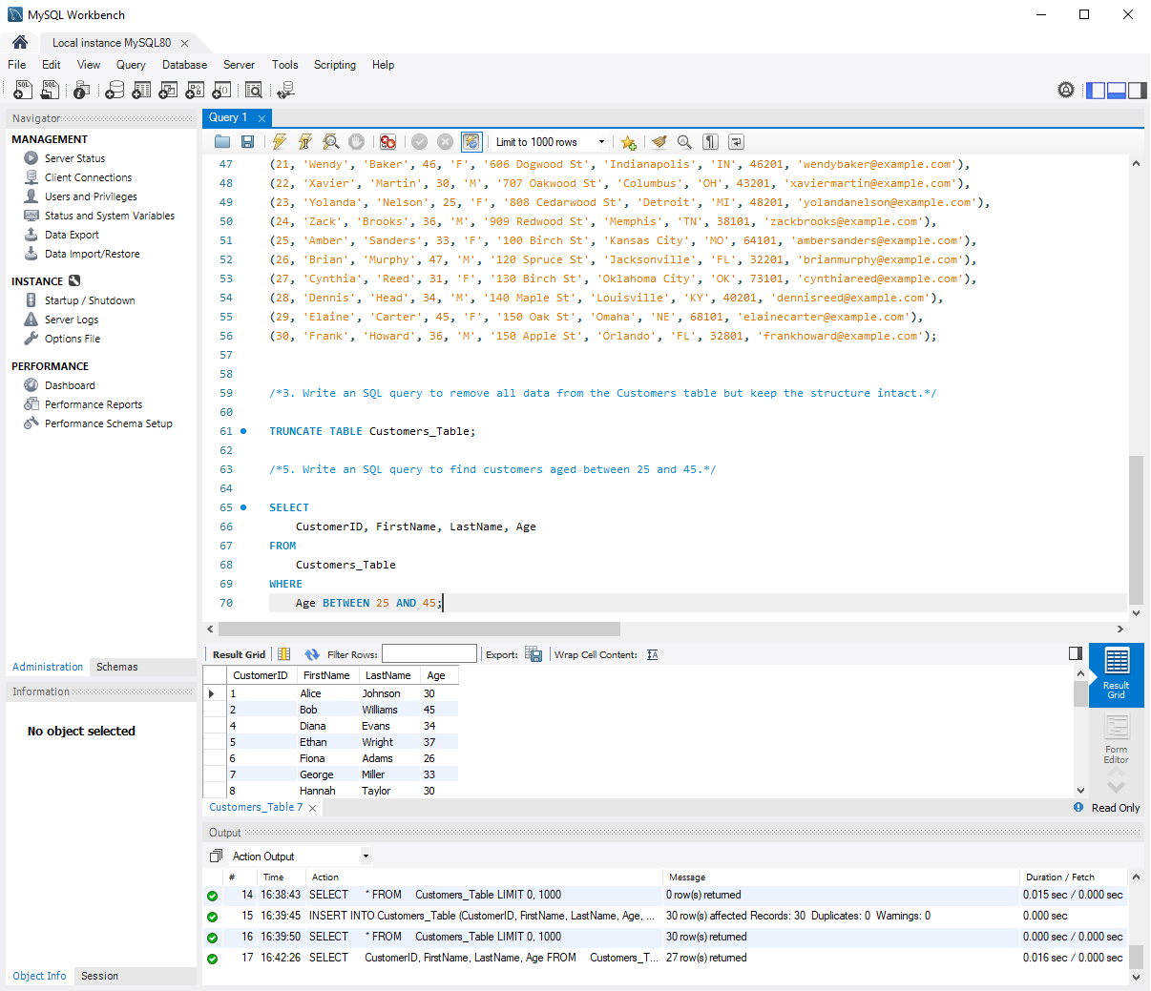

6. Retrieve customers whose Zip Code falls between ‘10000’ and ‘50000’.

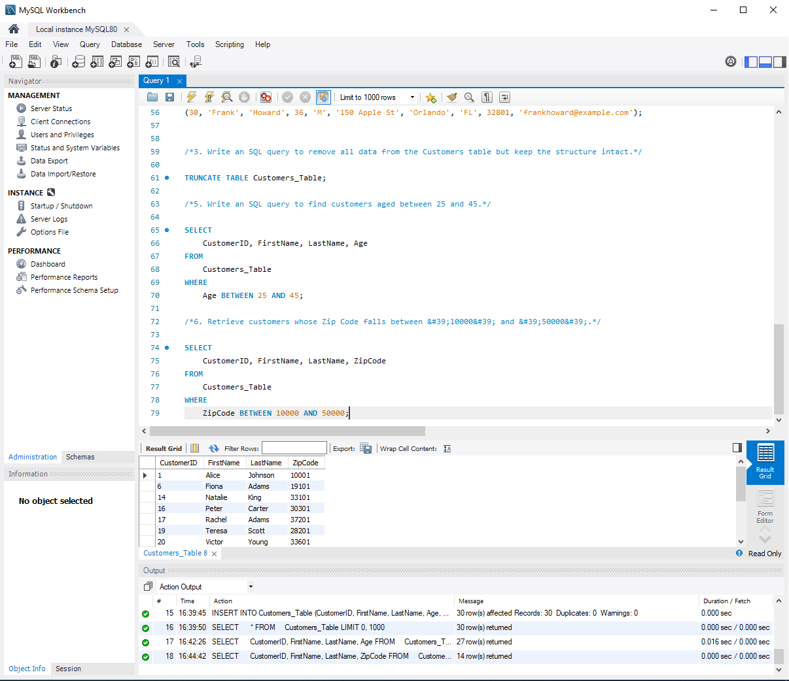

7. Get a list of customers with Customer Id between 10 and 20, ordered by LastName.

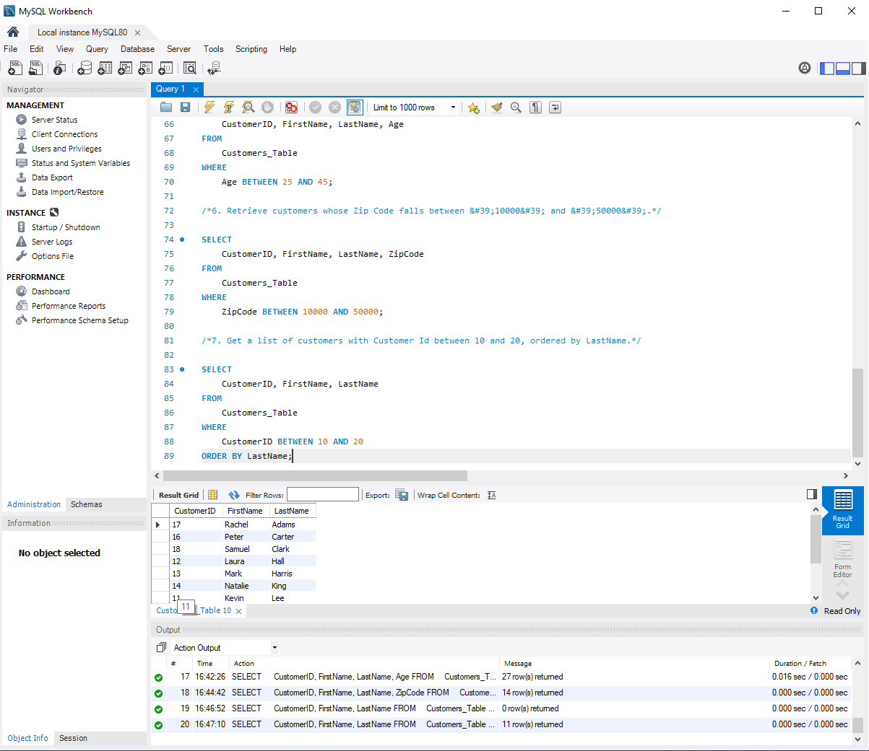

8. Write a query to find customers not in the age range of 30 to 50.

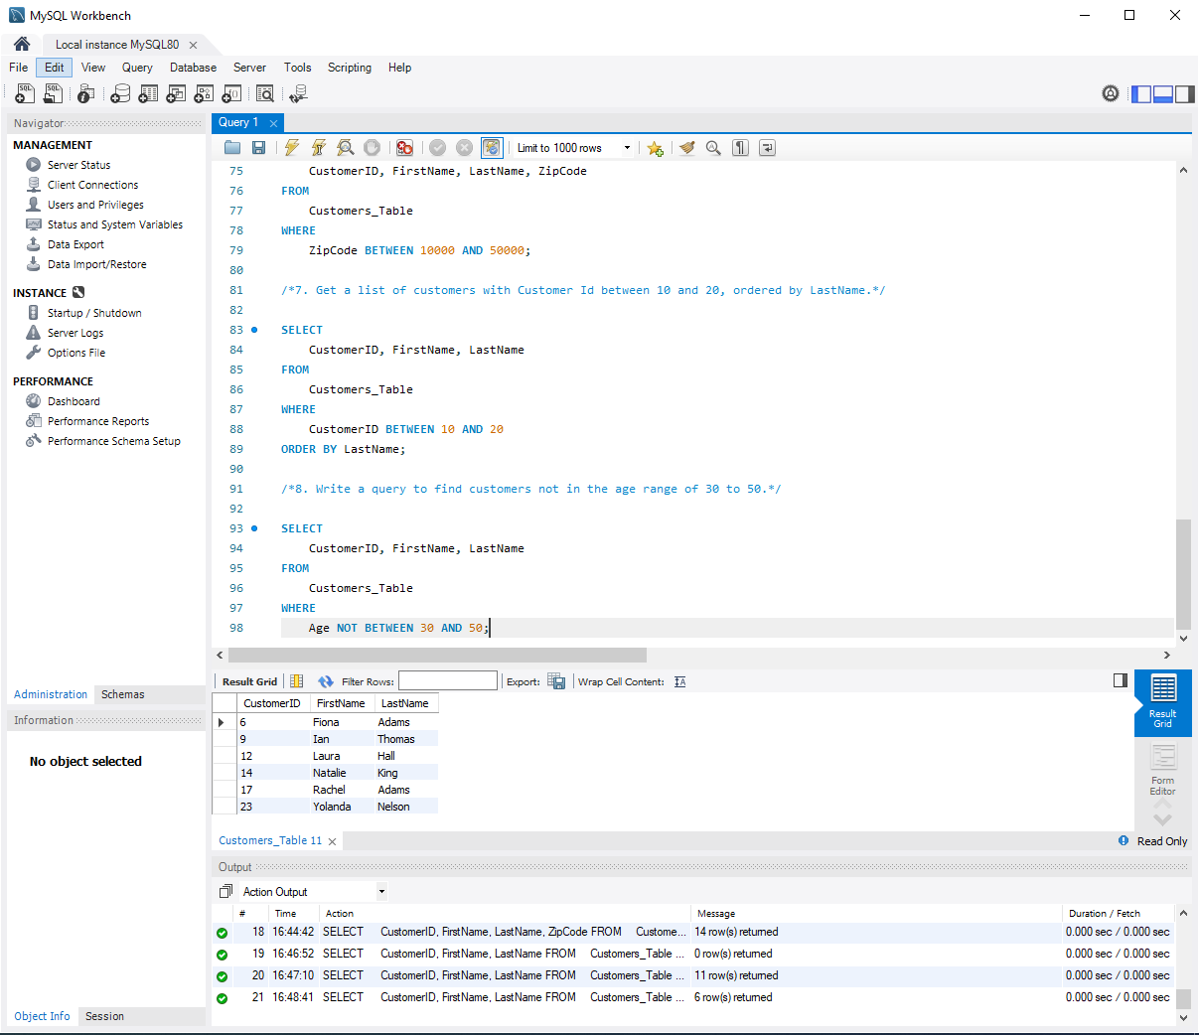

9. Retrieve all customers sorted by FirstName in ascending order.

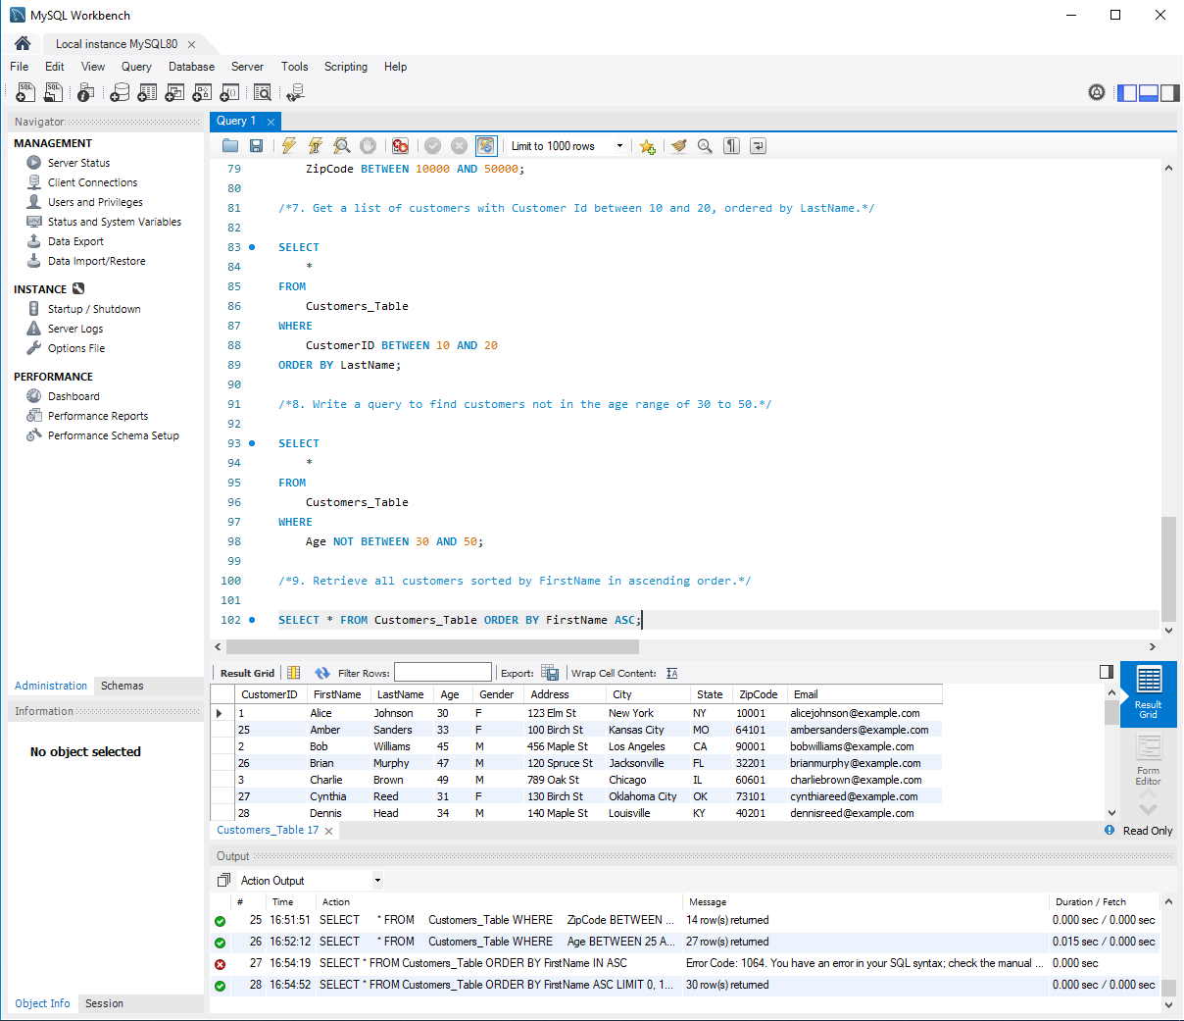

10. Write a query to list customers sorted by Age in descending order.

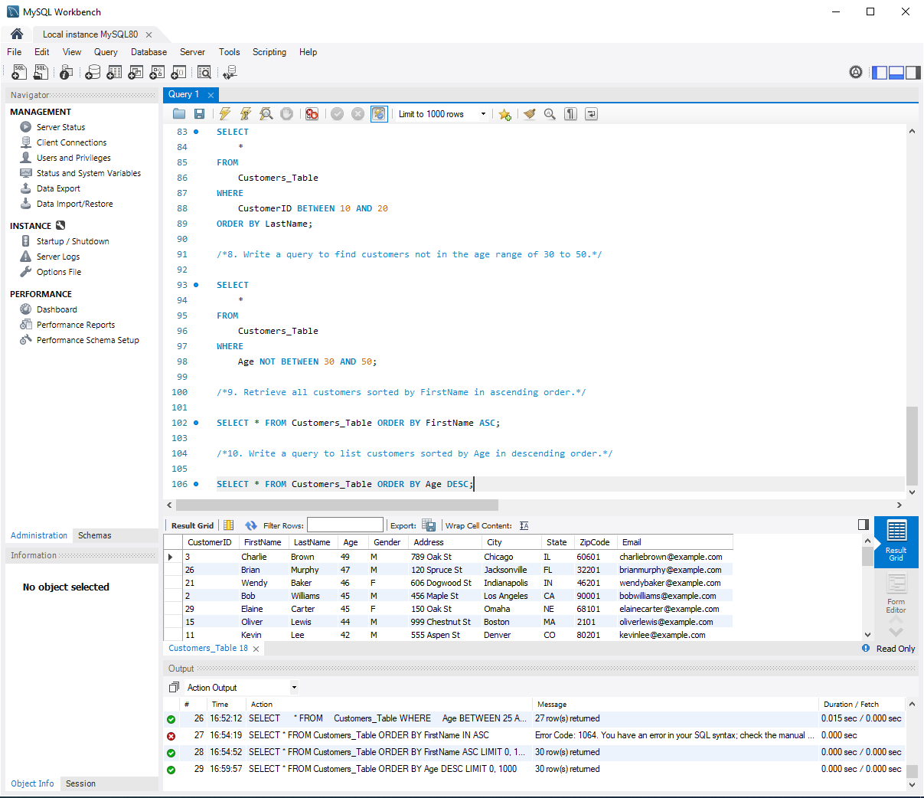

11. Get all customers ordered first by State (ascending) and then by City (descending).

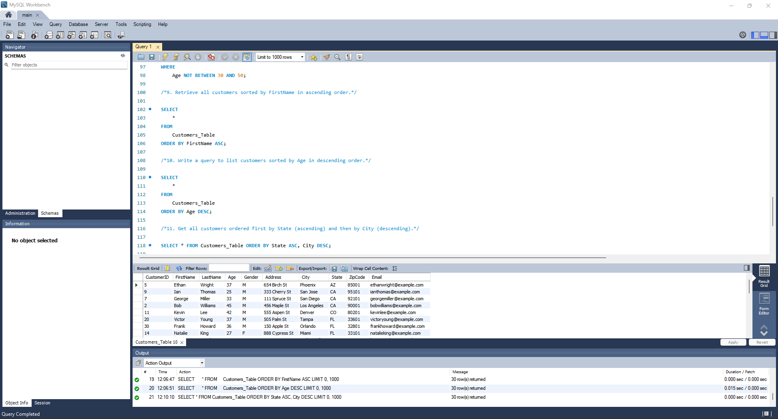

12. What happens if you use ORDER BY 2 DESC? Explain with an example.

Ans. The 2 in ORDER BY 2 DESC refers to the second column in the SELECT list, which is FirstName. The result is sorted in descending order of the FirstName column. Example Screenshot attached.

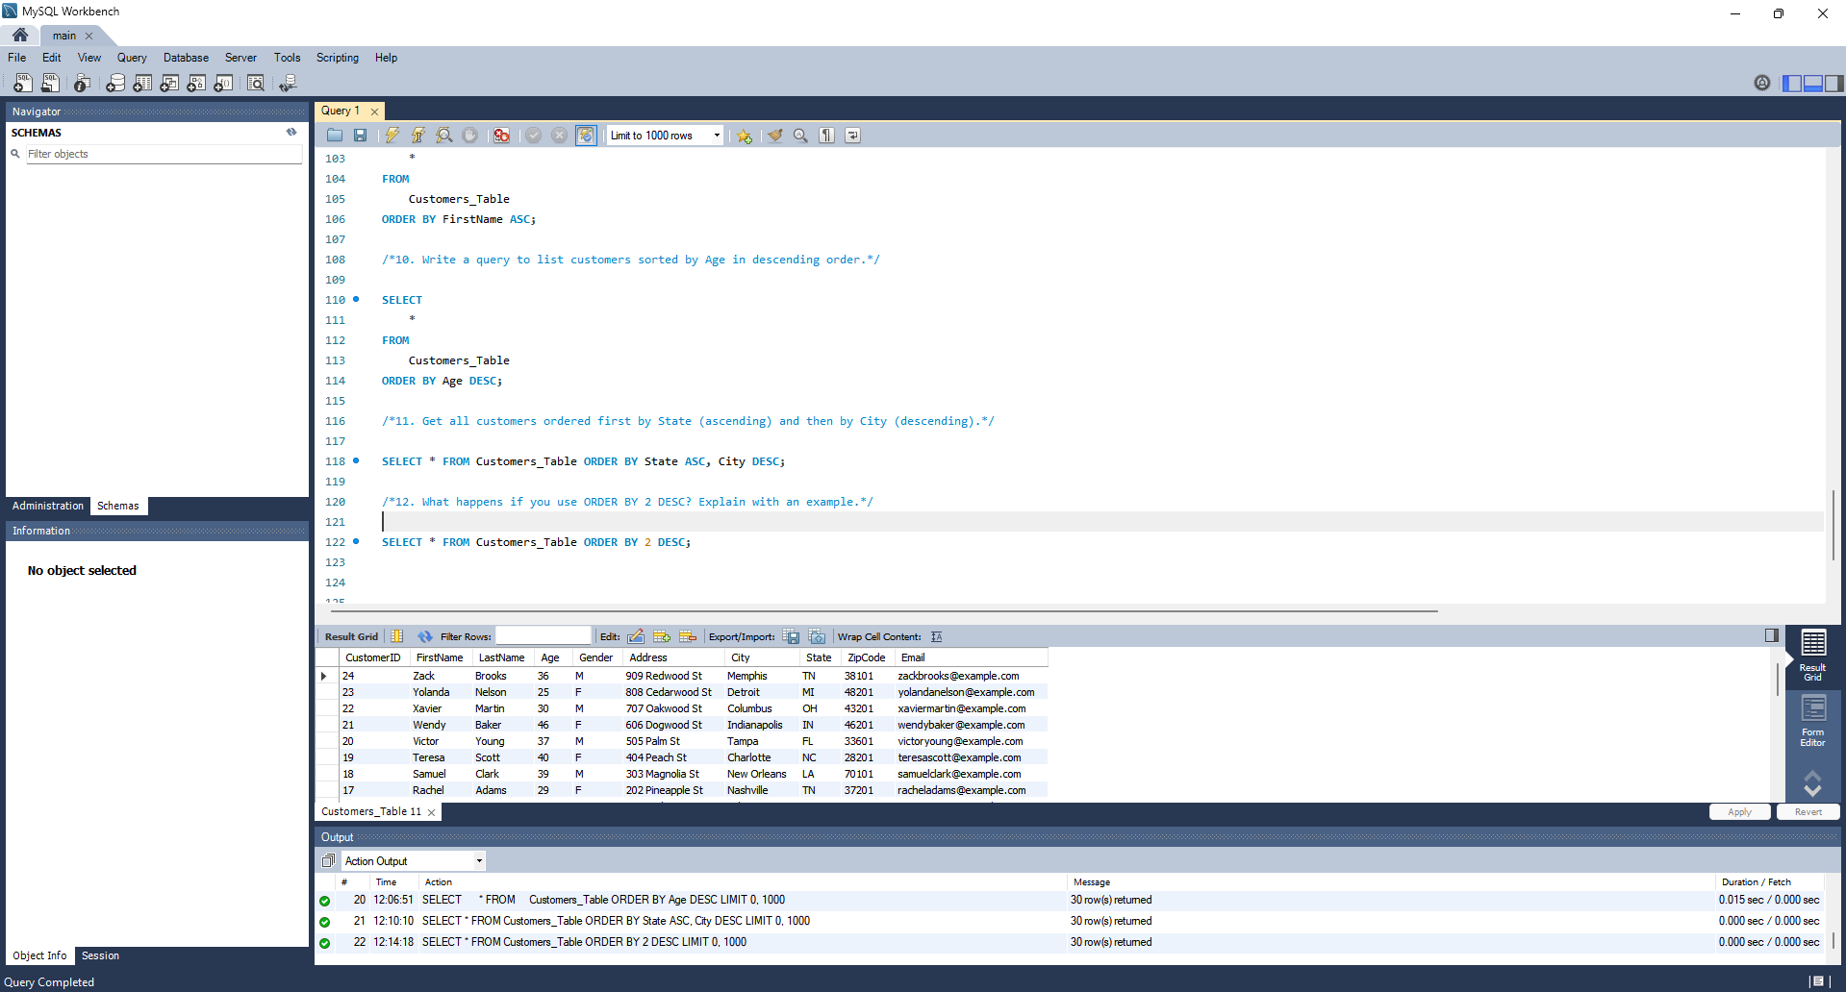

13. Modify a query to sort customers by State, then Age (descending), then FirstName.

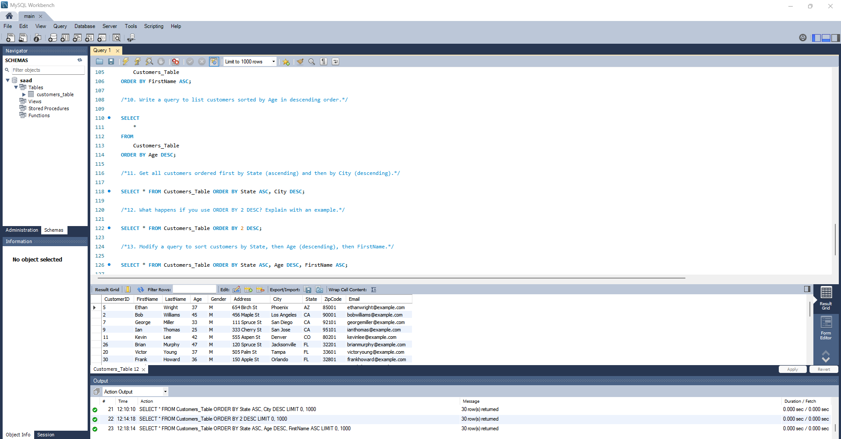

14. Write an SQL query to count the number of customers in each State.

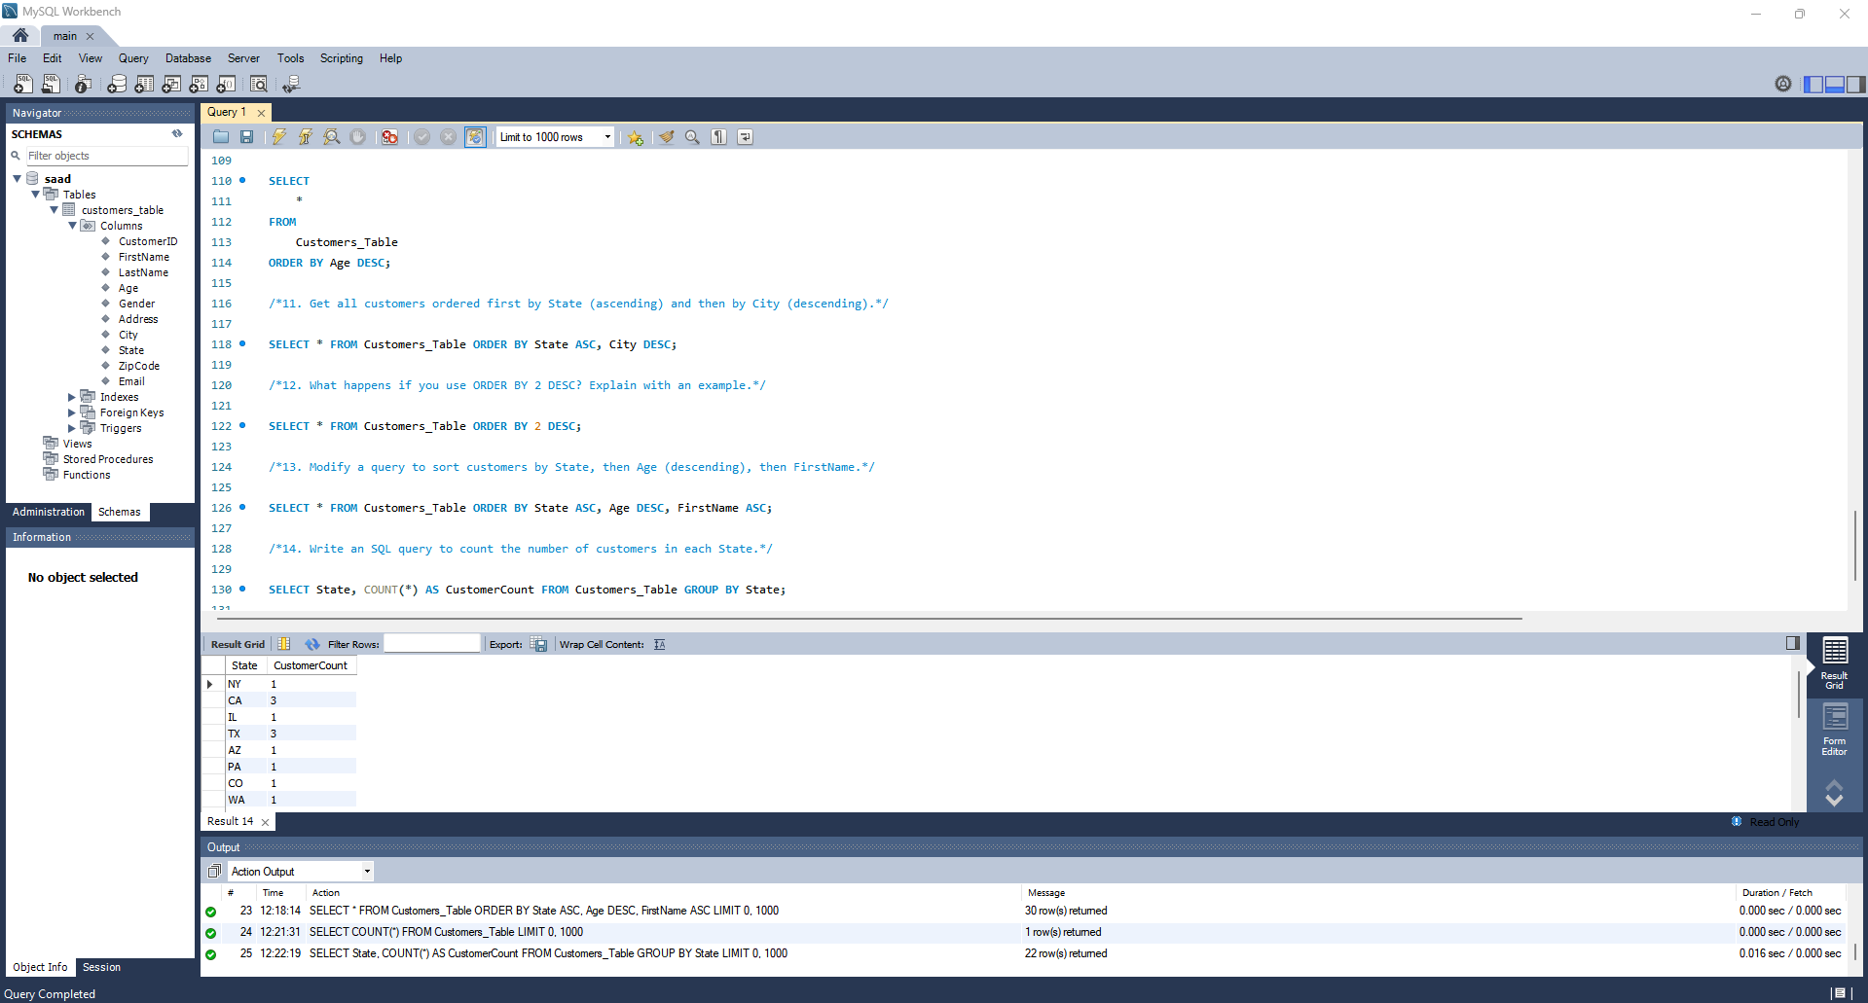

15. Retrieve the average age of customers in each state.

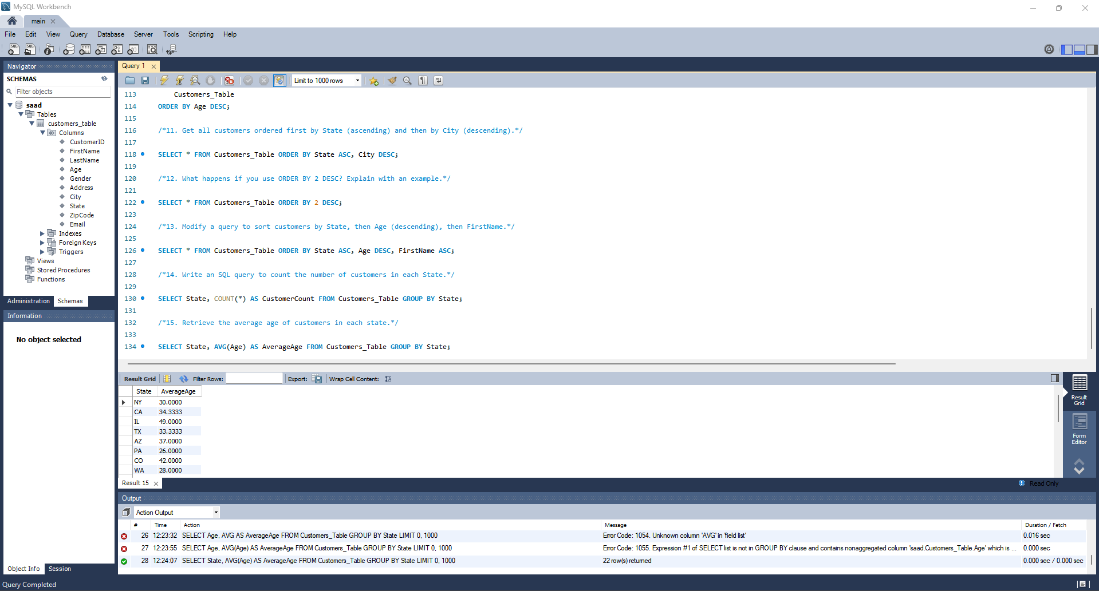

16. Find out how many customers belong to each gender (M/F).



17. List all cities along with the total number of customers in each city.

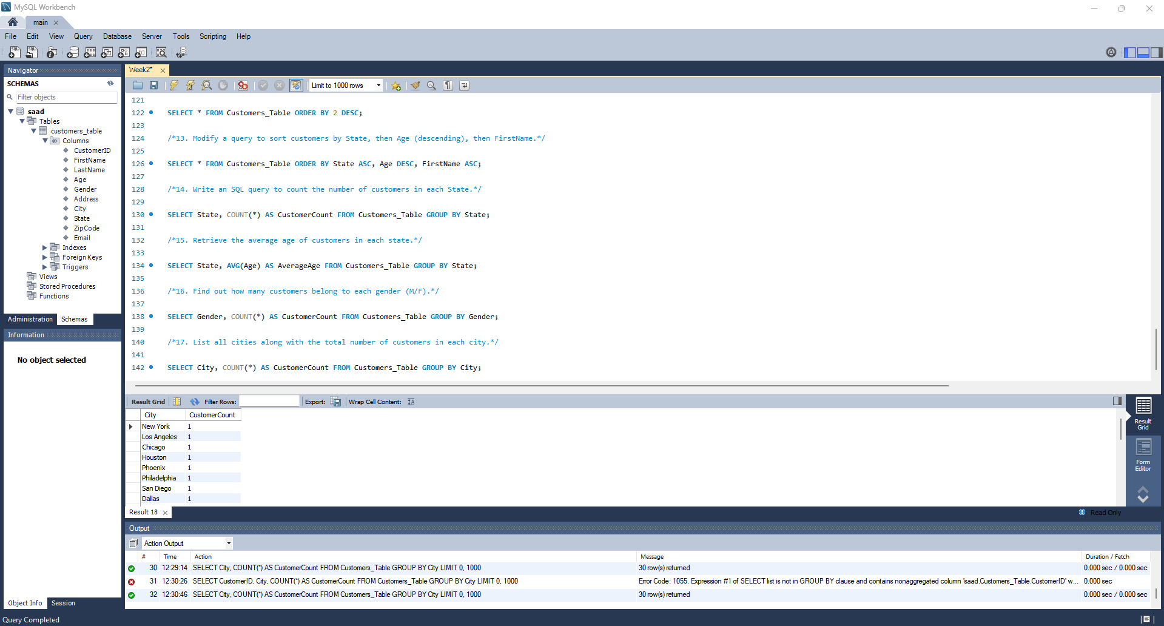

18. What will happen if you try to use GROUP BY without an aggregate function like COUNT() or SUM()?

Ans. If you use GROUP BY without an aggregate function SQL will still group the data, but the result may not be meaningful. SQL will return one row per group, but only one value for the non-grouped columns (which may be random or database-dependent).

19. Write an SQL query to combine the list of all customers from California (CA) and New York (NY).
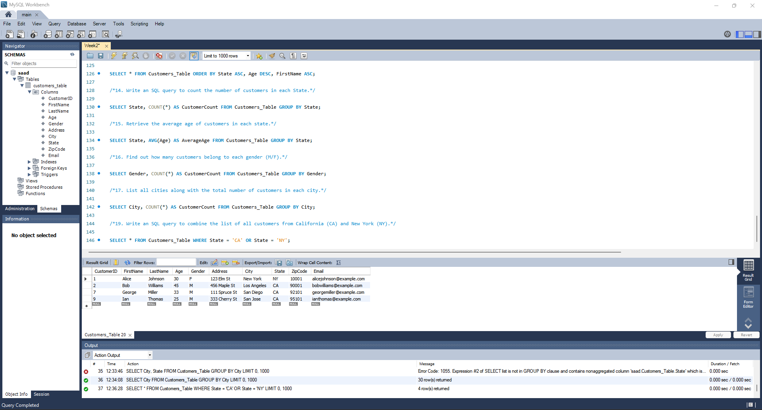

20. Retrieve all customers aged below 30 and all customers aged above 50 using UNION.

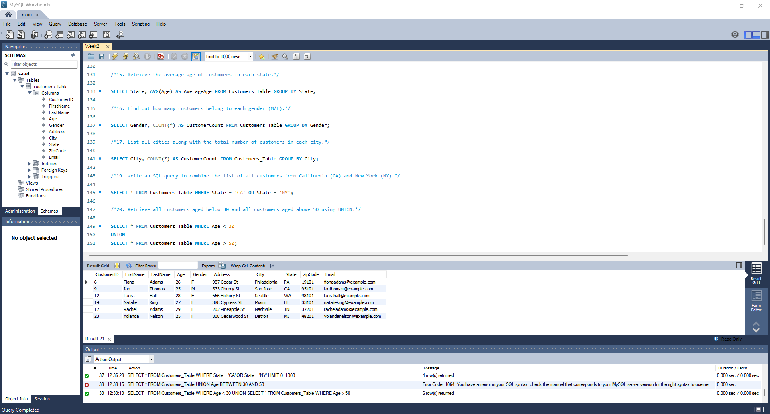

21. Write a query to display unique cities from the Customers table using UNION.

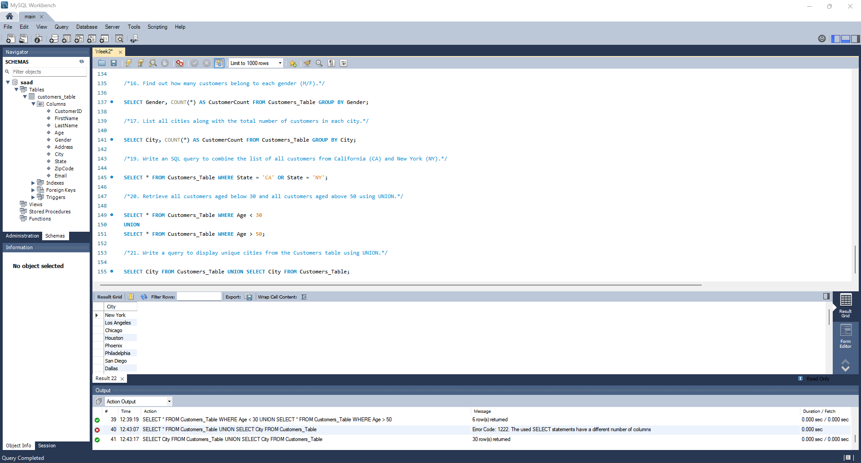

22. What happens if column counts in SELECT statements used in UNION do not match?

Ans. The query will result in an error.

23. Why does UNION remove duplicates while UNION ALL does not? Explain with an example.

Ans. UNION removes duplicates because it performs an implicit DISTINCT operation. UNION ALL does not remove duplicates; it simply appends the results.

24. Write an SQL query to get customers from TX and TX again, and observe duplicate records.

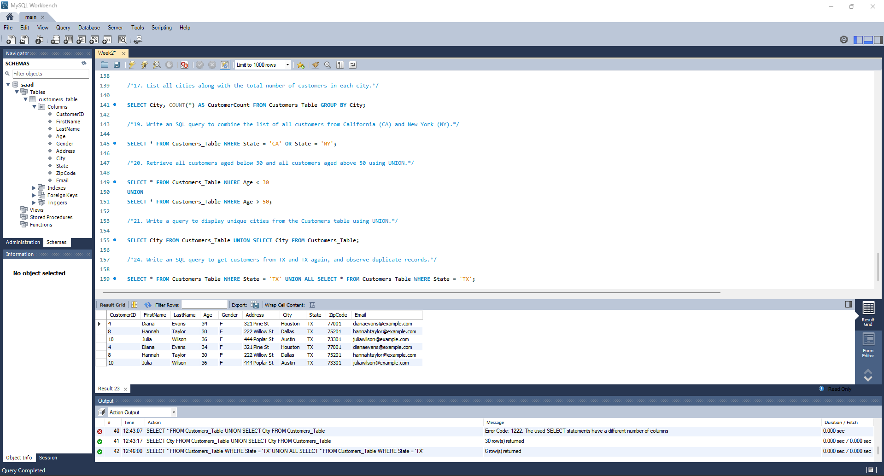

25. Retrieve all customers aged below 30 and above 50 ensuring duplicates are not removed.

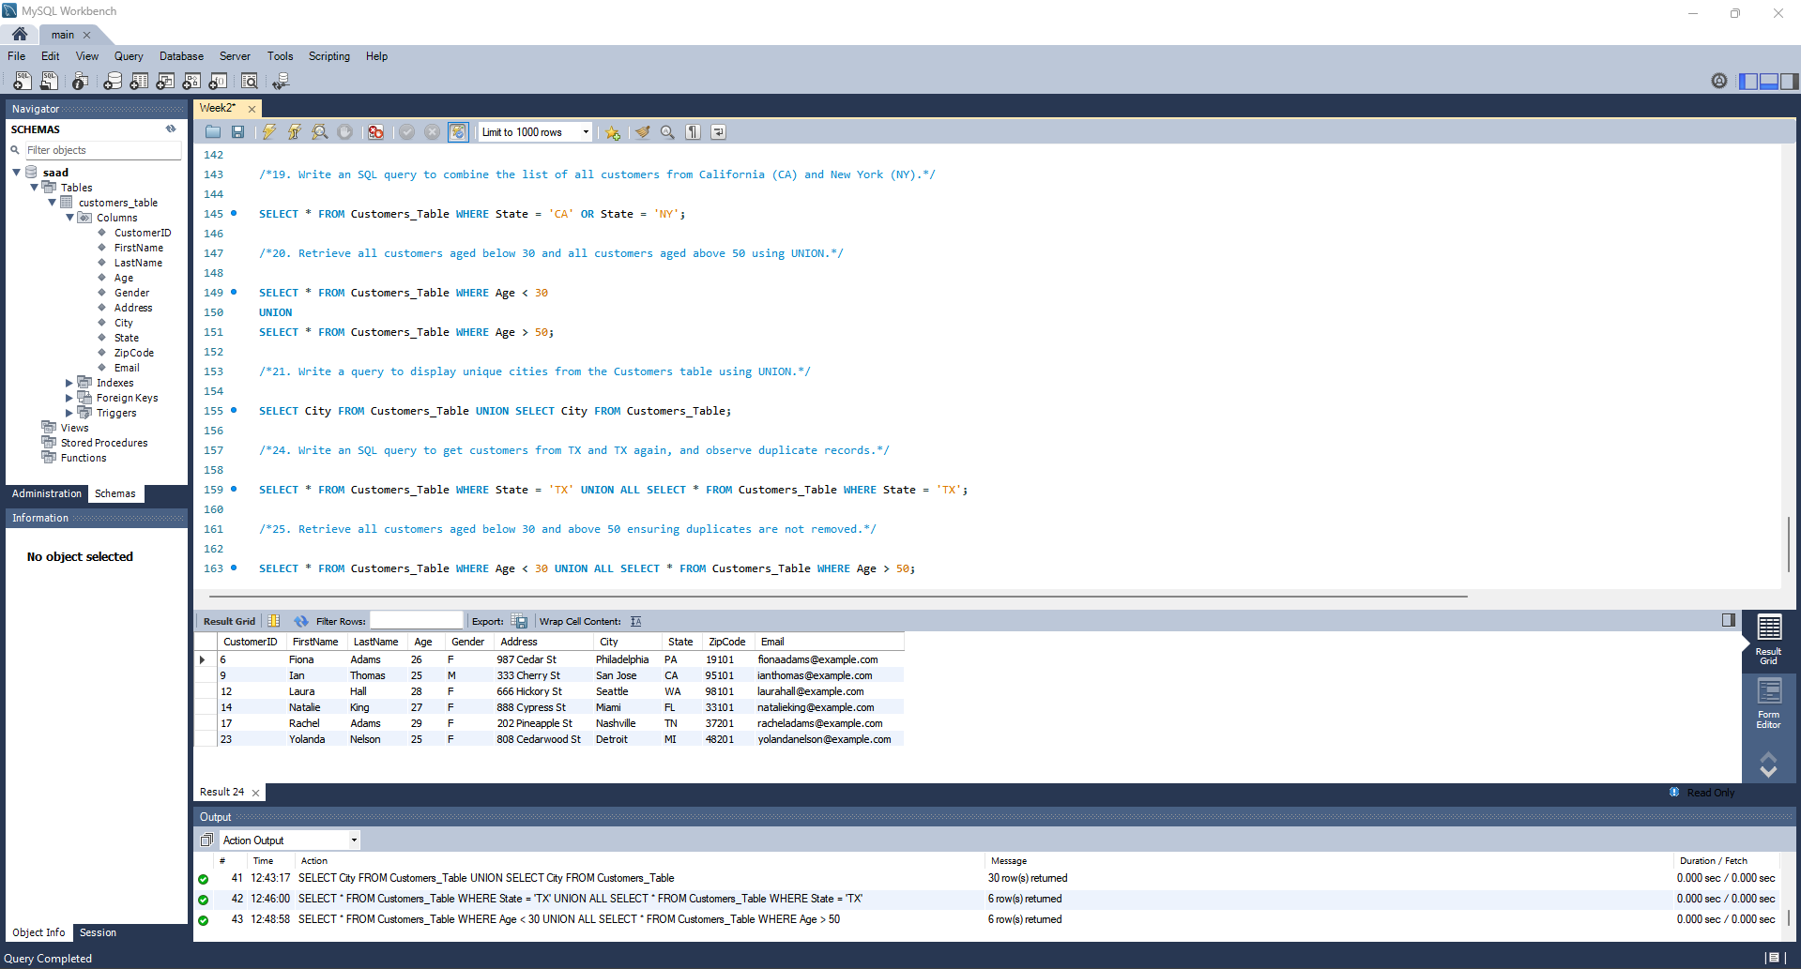

26. What happens when you use ORDER BY in a UNION ALL query? Where should it be placed?

Ans. ORDER BY must be placed at the end of the UNION ALL query and applies to the entire result set.

27. Why is UNION ALL generally faster than UNION? Explain in terms of query execution.

Ans. UNION ALL is faster than UNION because it avoids duplicate removal.

Query Execution Steps for UNION | Query Execution Steps for UNION ALL
Executes both SELECT queries. | Executes both SELECT queries.
Sorts the combined results. | Simply appends results without sorting or duplicate removal.
Removes duplicates (requires comparison of all records). | Returns the combined result set.
Returns the unique result set.

28. What will happen if the columns in two SELECT statements used in UNION ALL have
different data types?

Ans. If the columns have different data types, the database will attempt implicit type conversion. However, if the types are incompatible, it results in an error.

